Appendix A1 Signup page with Please fill out this field massage  
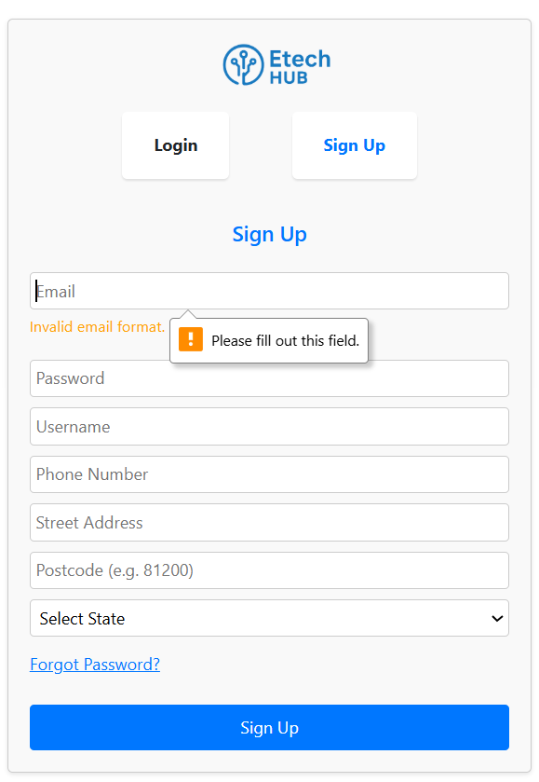  
  
Appendix A2 Login page show massage please use a different email  
  
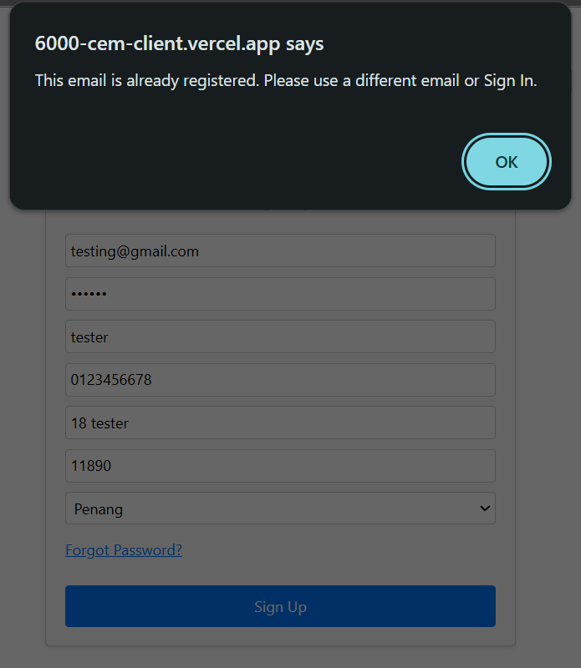

Appendix A3 Login page show massage please include an @ in the email address 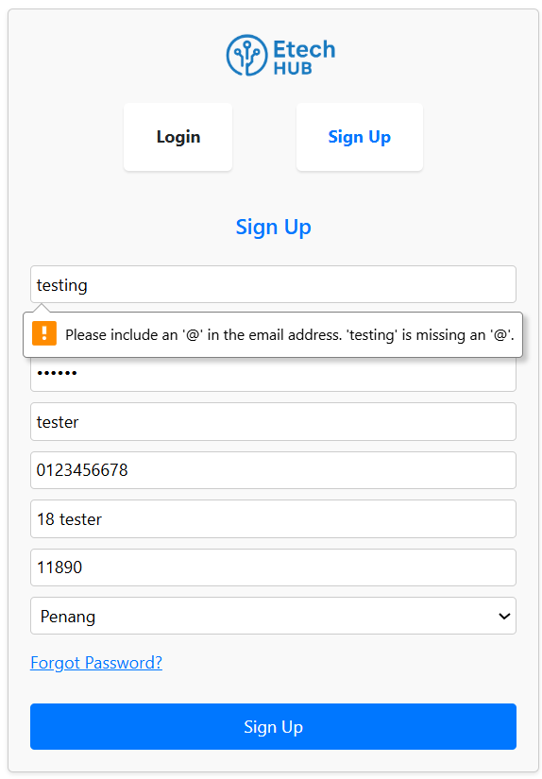  
  
Appendix A4 Login page show massage Password must be at least 6 characters.  
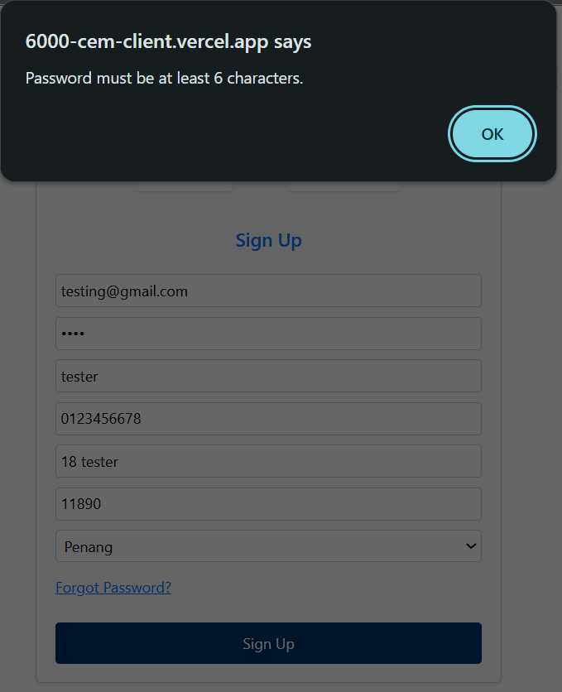

Appendix A5 Login page show massage Phone number must be 10 or 11 digits  
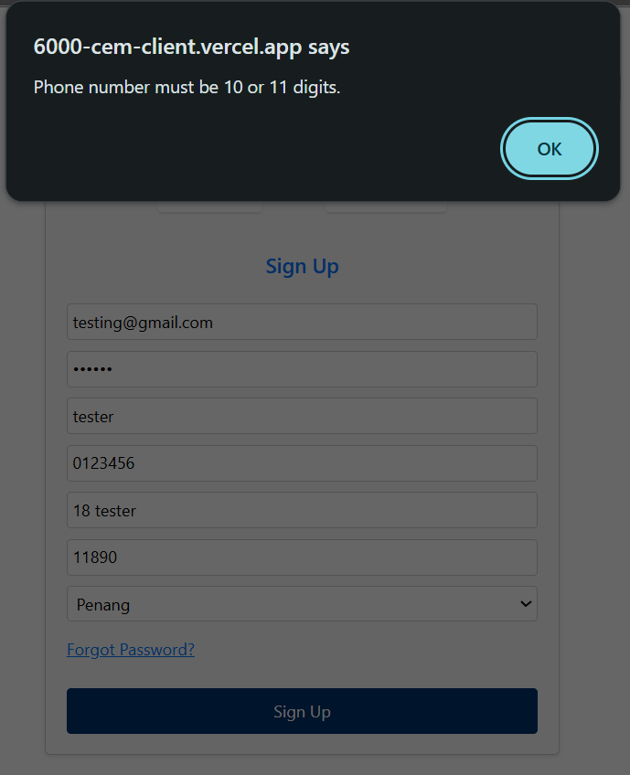

Appendix A6 Login page show massage Please enter a valid address

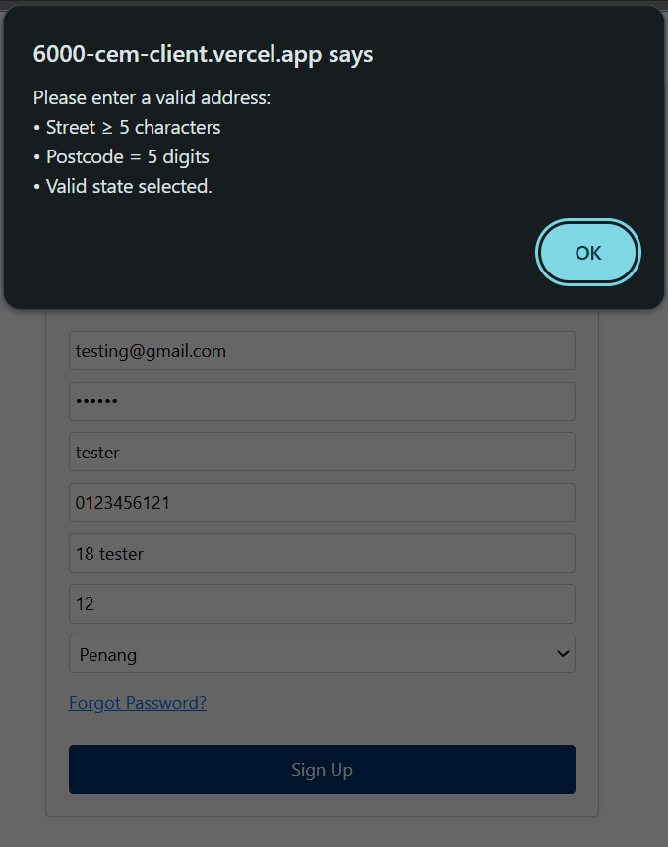

Appendix A7 The Sign Up button responds correctly when clicked, successfully triggering the registration process.

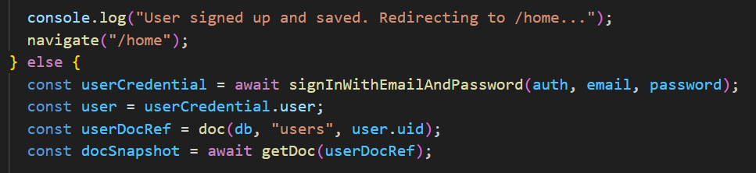

Appendix A8 Login Page show massage Please fill out this field  
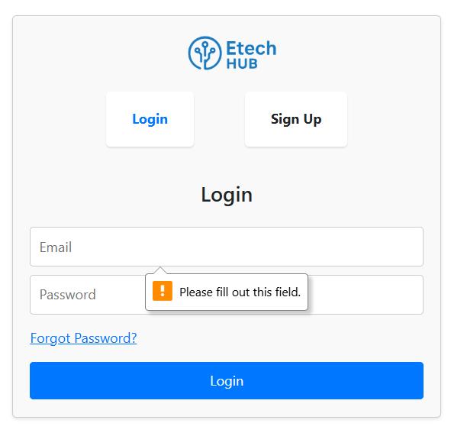

Appendix A9 Login Page show massage invalid login credentials  
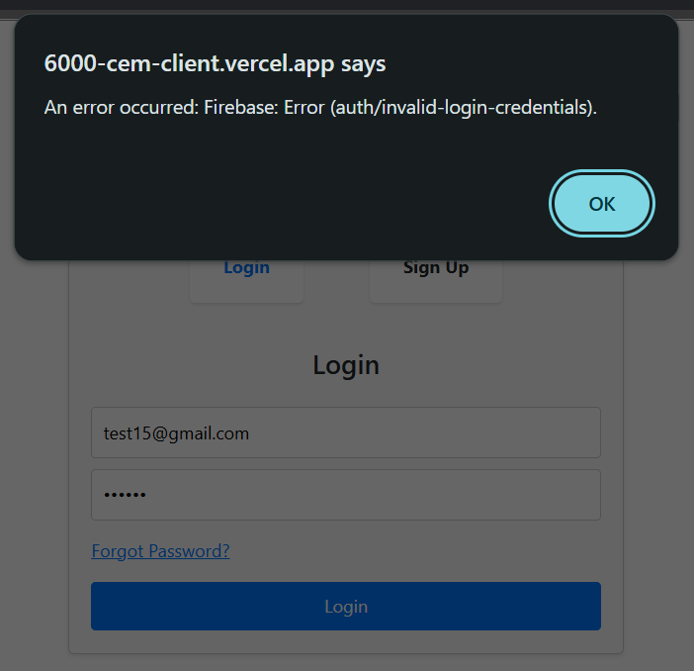

Appendix A10 Login Page show massage Password must be atleast 6 characters  
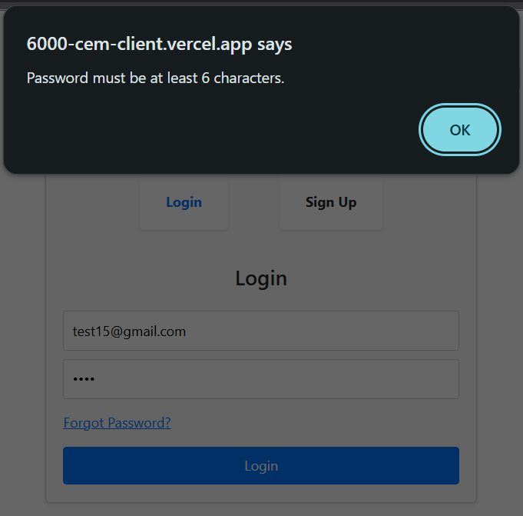

Appendix A11 Password reset page show massage auth/invalid-email  
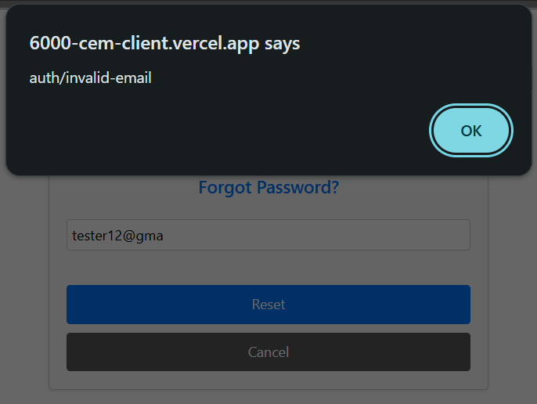

Appendix A12 Reset password page show massage check your email

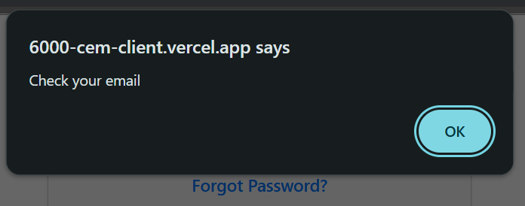

Appendix A13 Reset password page show massage the password must be atleast 6 characters long  
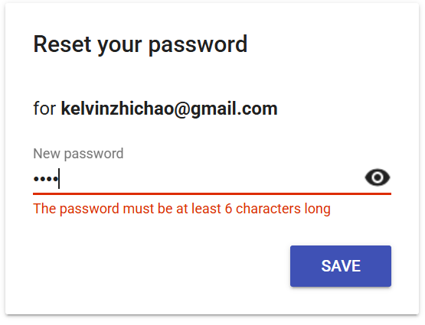

Appendix A14 Reset password page show massage try ressetting your password again  
  
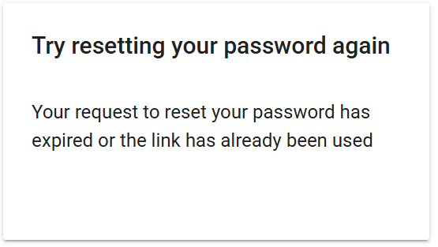

Appendix A15 Homepage loads without errors and delays  
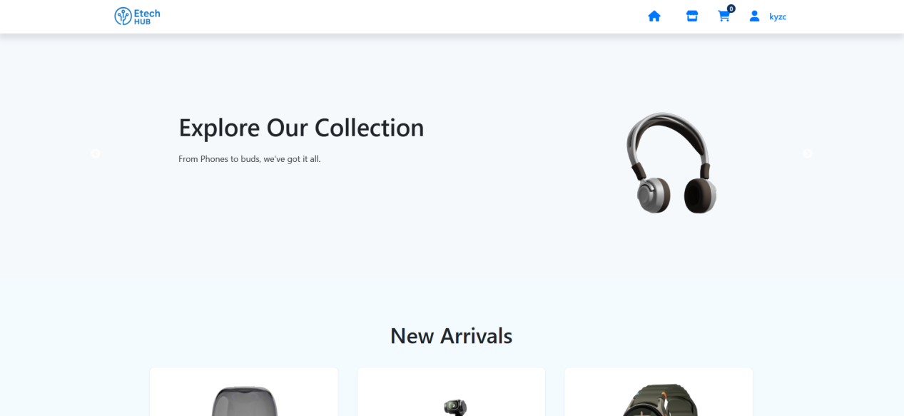  
  
Appendix A16 Navigation bar are clickable and route correctly  
  
  
Appendix A17 Homepage New arrivals product displayed correctly  
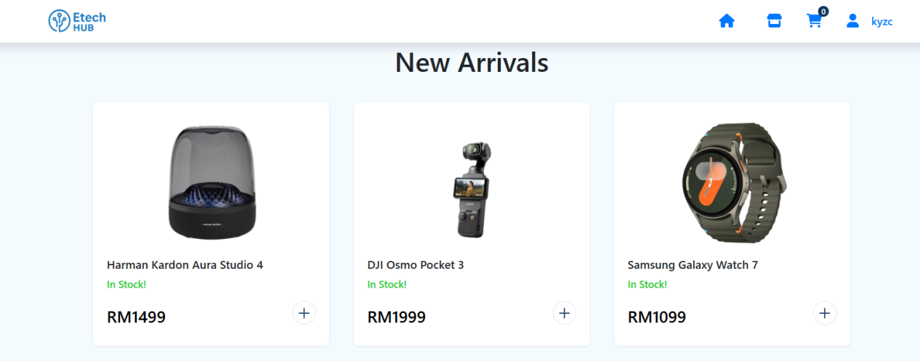  
  
Appendix A18 Show product details page   
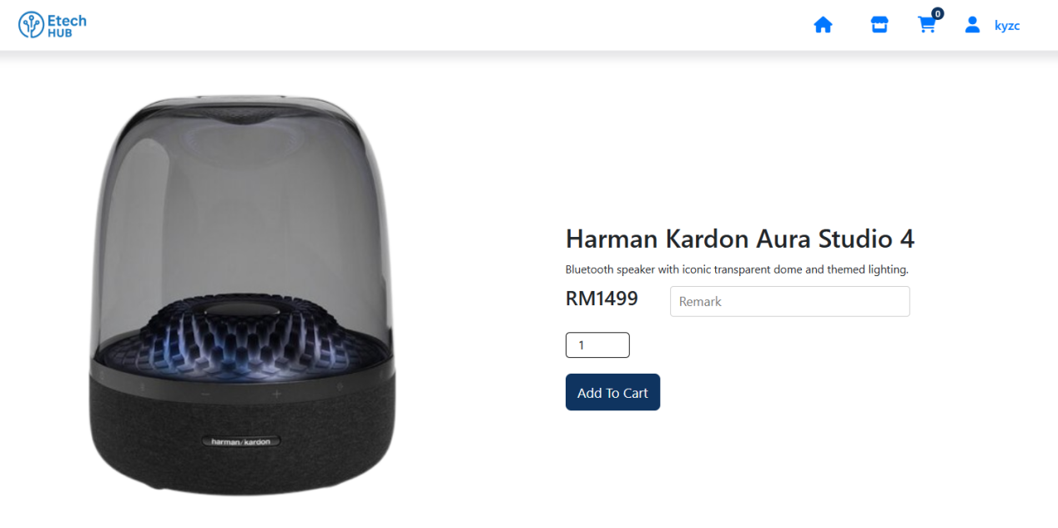

Appendix A19 Show Home page navigation bar is still remain in place when page reached bottom  
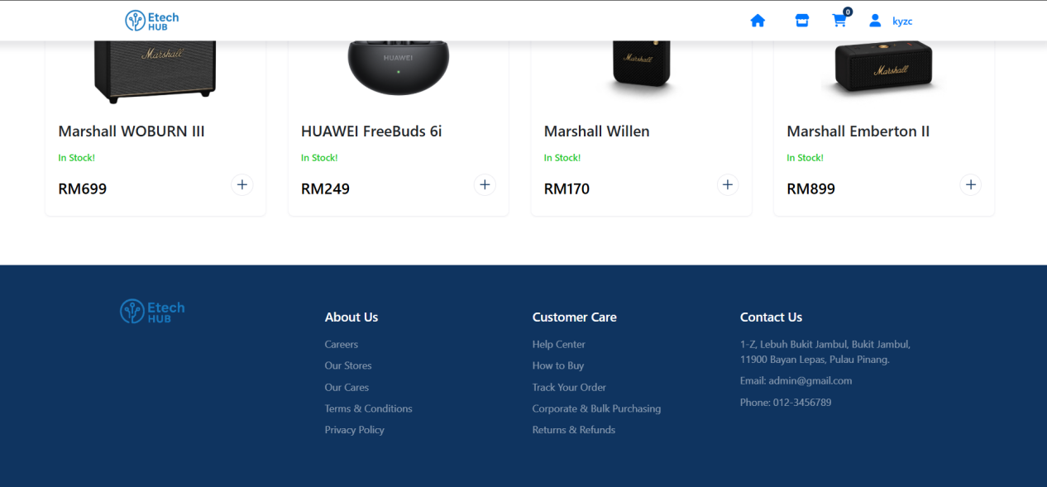  
  
Appendix A20 Show Home page footer  


Appendix A21 Show home page with welcome banner   
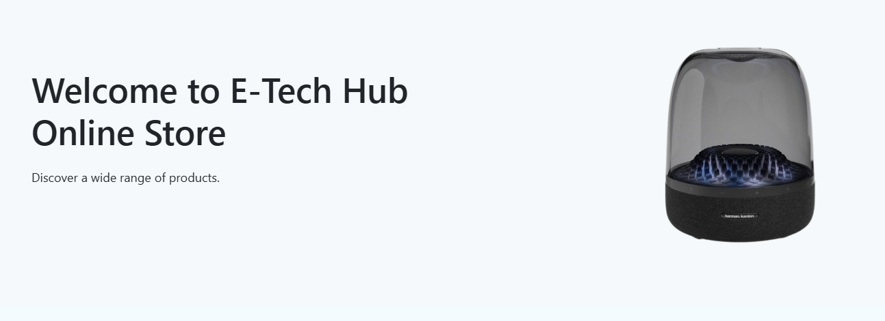  
  
Appendix A22 Show when navigation cart icon reflect correct number of items  
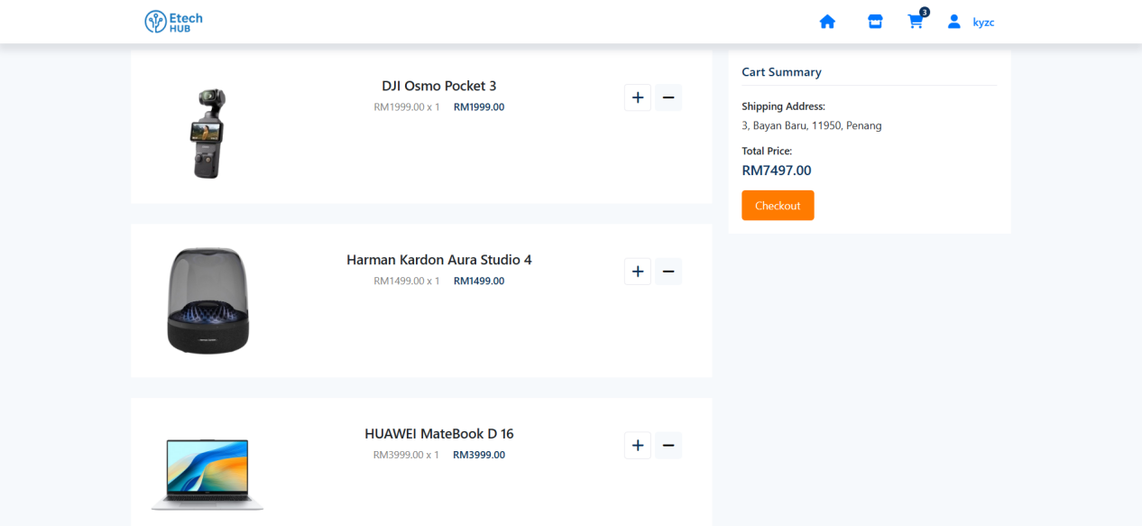

Appendix A23 Navigation bar show username   


Appendix A24 Show code snip of Sign Out  
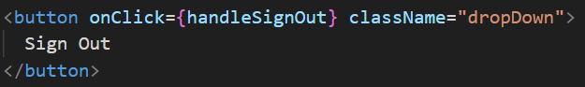

Appendix A25 Shop page   
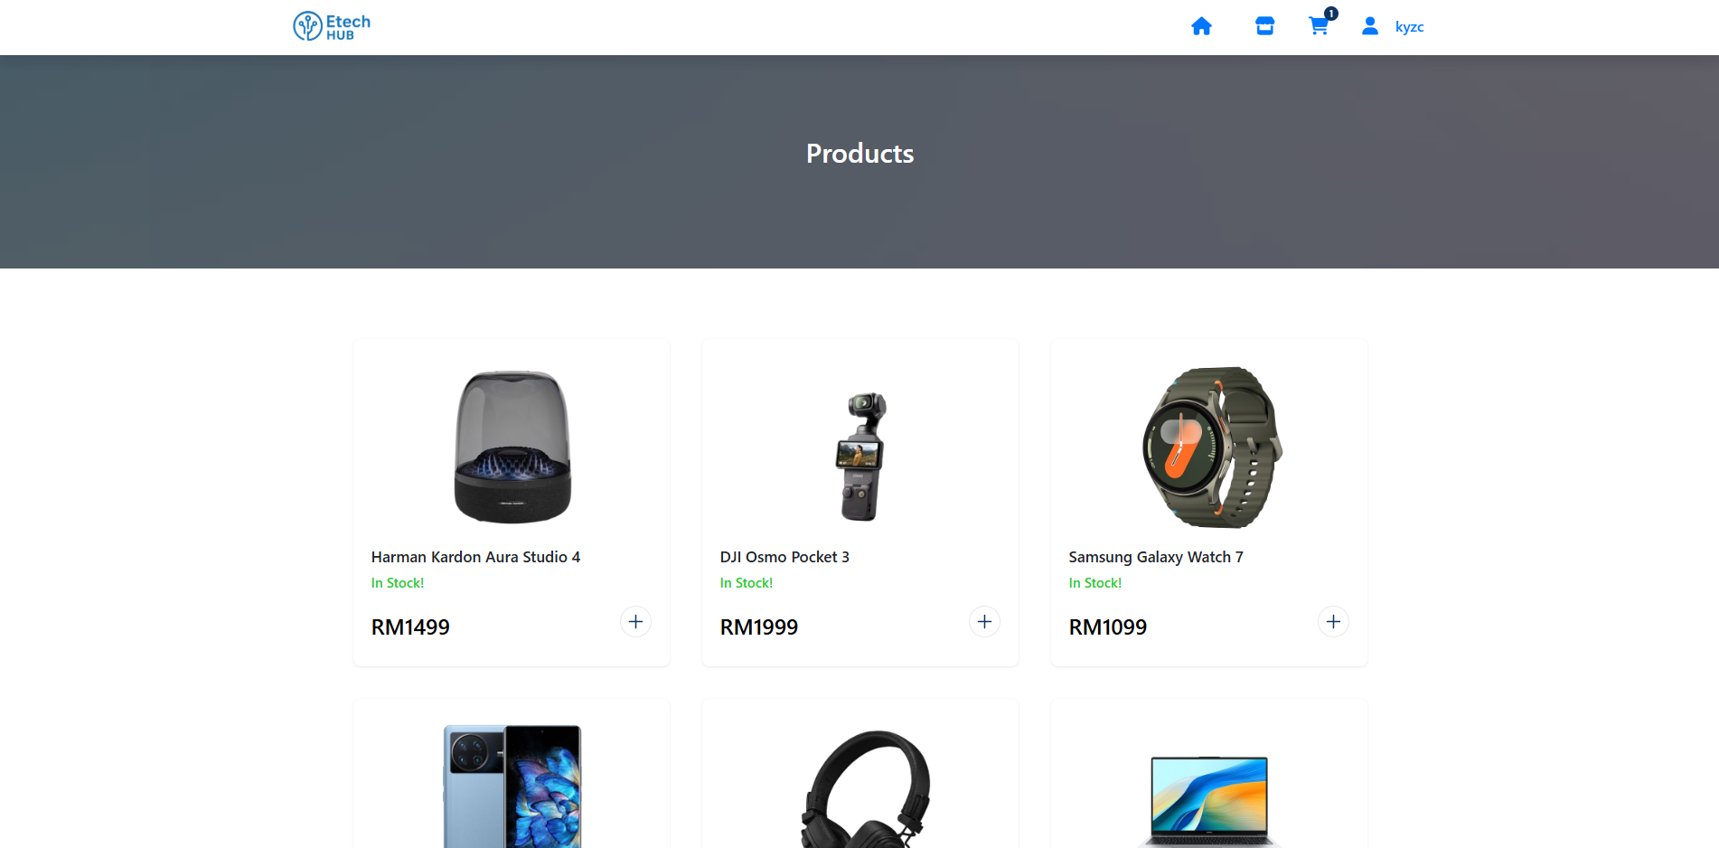

Appendix A26 Shop page product shown clearly with details



Appendix A27 Product images shown clearly without distortion

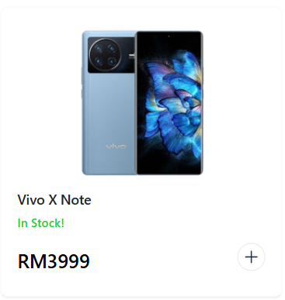

Appendix A28 Product details page 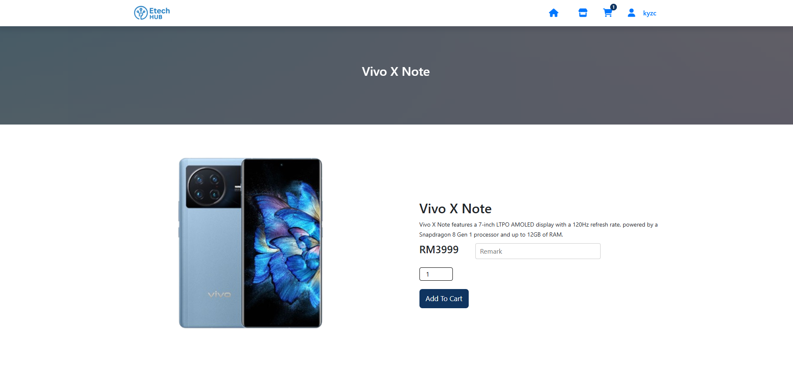

Appendix A29 Add to cart button work properly  
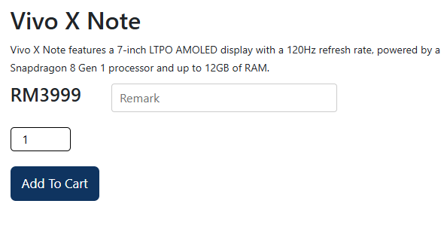  
Appendix A30 Firestore shown price amount matched with the webpage  
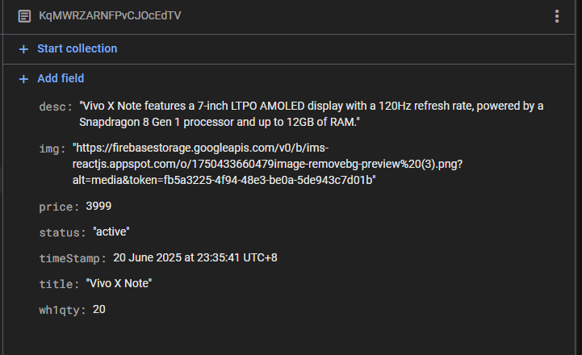

Appendix A31 Firestore shown item is disabled  
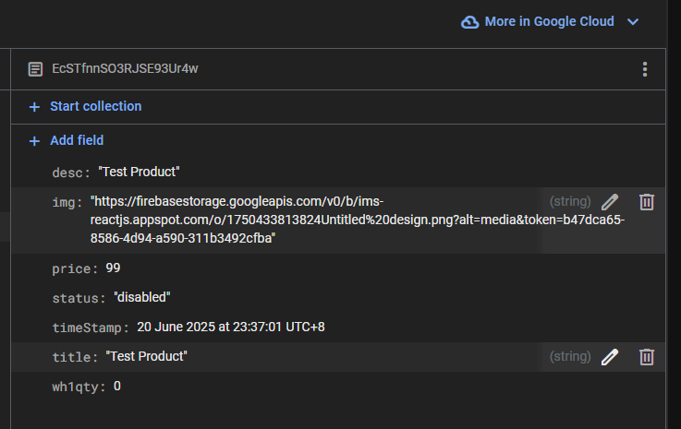  
  
Appendix A32 Product show massage when item is low amount  
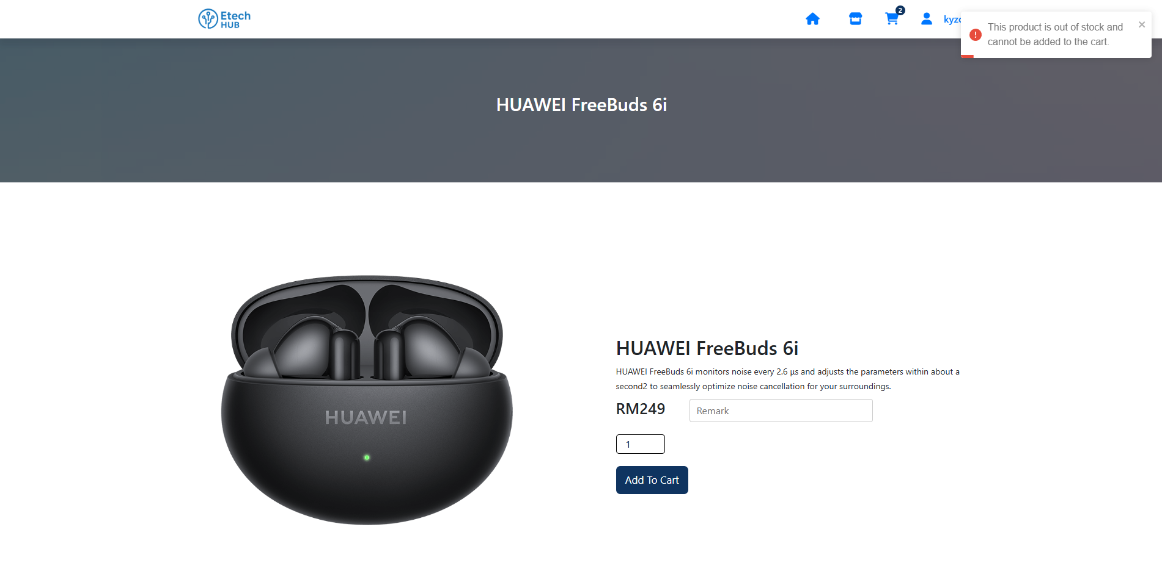

Appendix A33 Cart Page loads without error

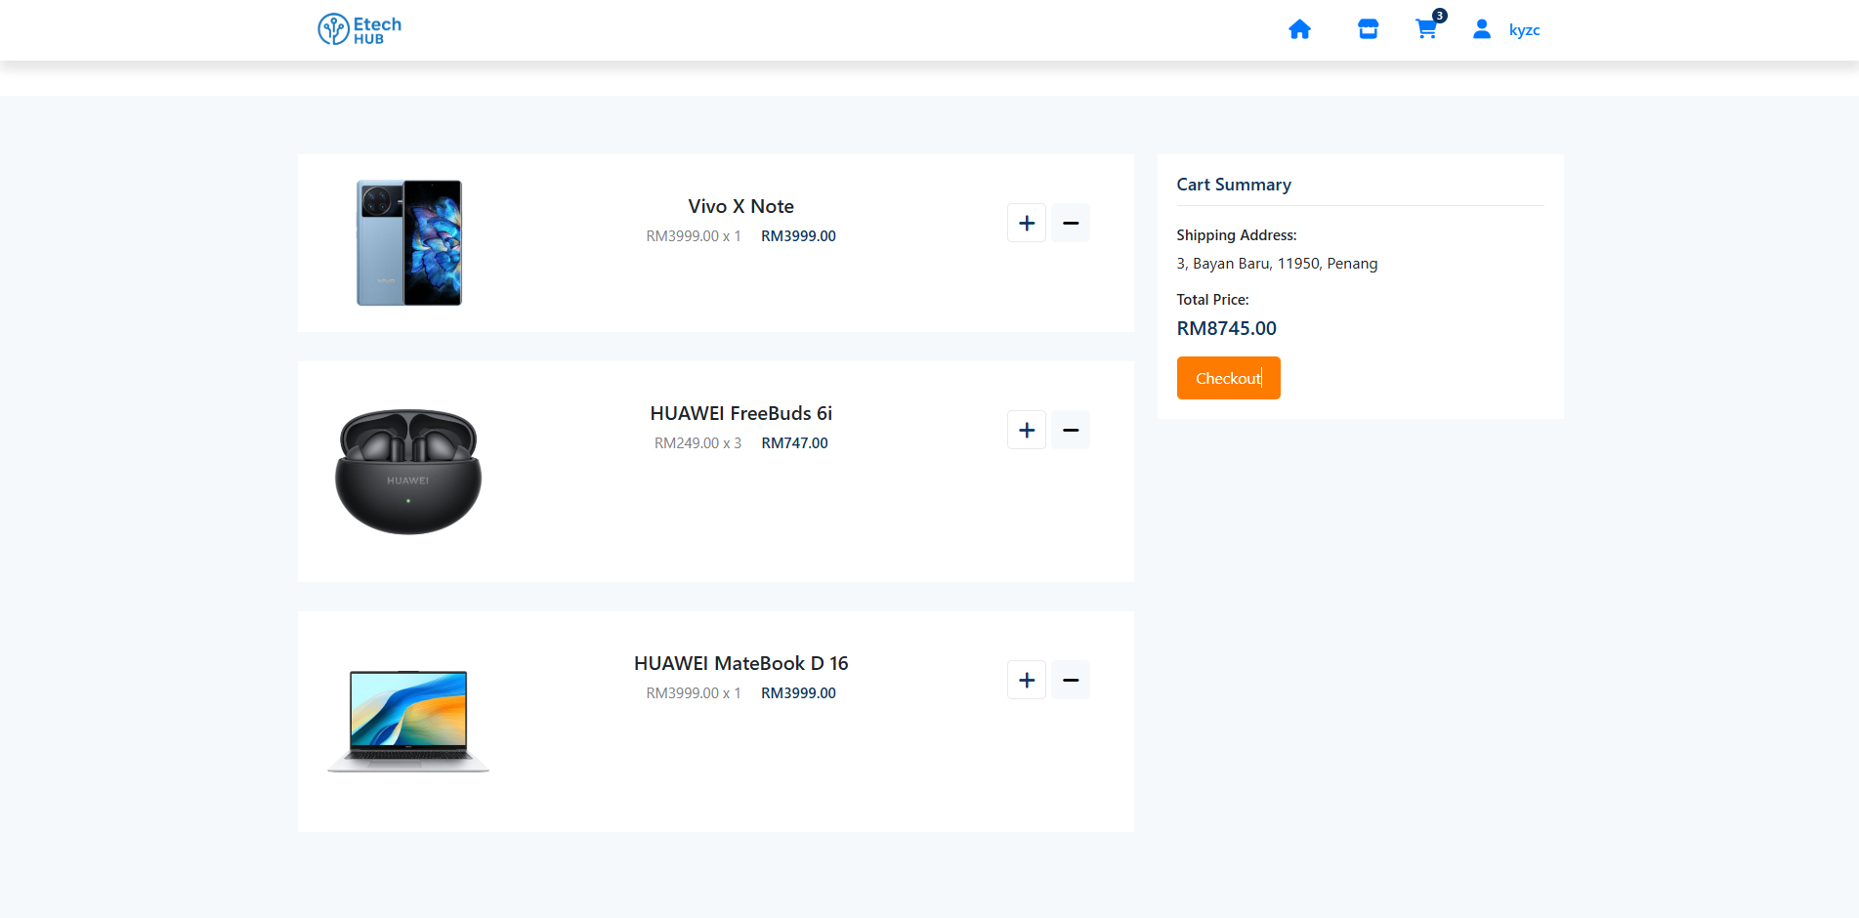  
  
  
Appendix A34 Cart item show with correct details  
  
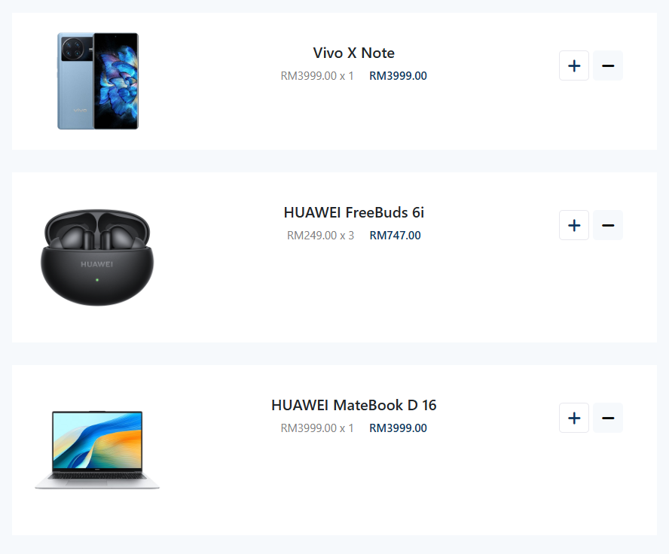

Appendix A35 Product total price is counted exactly amount correctly  
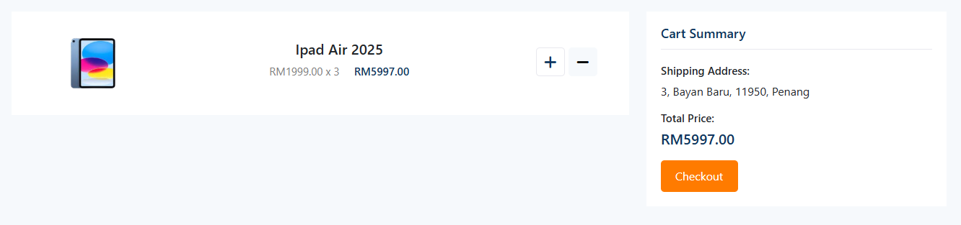  
  
  
  
  
Appendix A36 Code snipped that show all item can be removed  
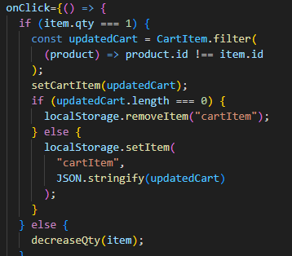  
  
  
Appendix A37 Cart page show that both item price added correctly  
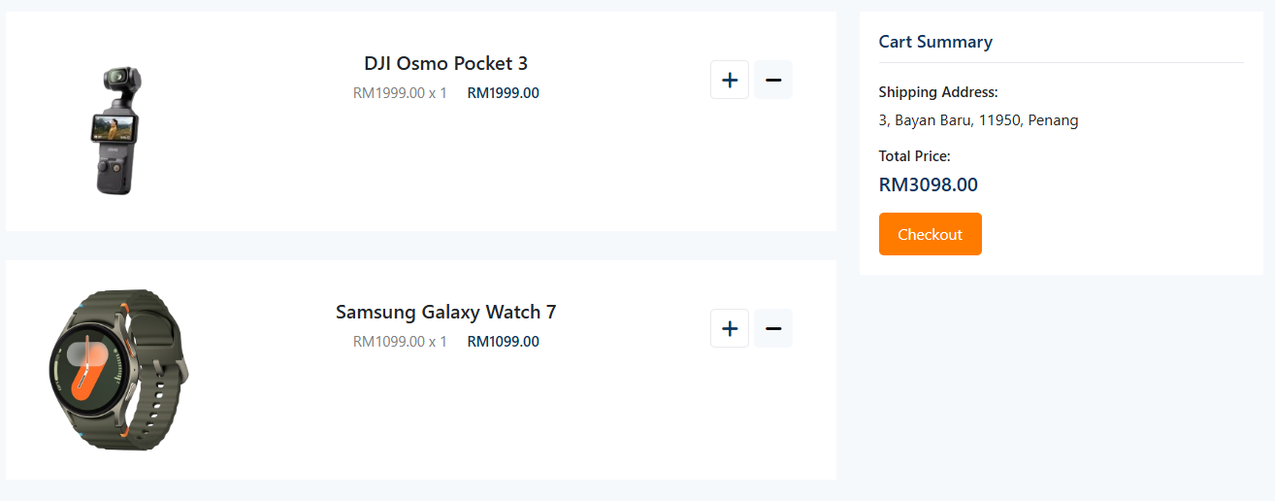

Appendix A38 Cart page when no item inside cart massage show No Items are in the Cart   
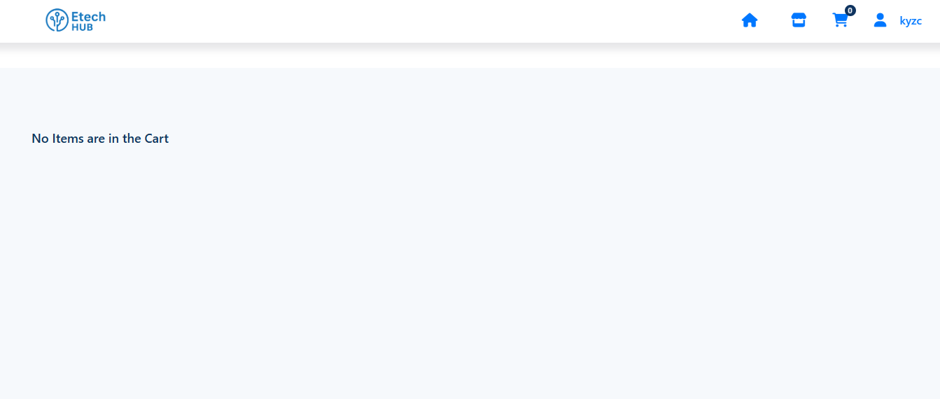  
  
  
Appendix A39 Cart page Checkout buttom working perfectly 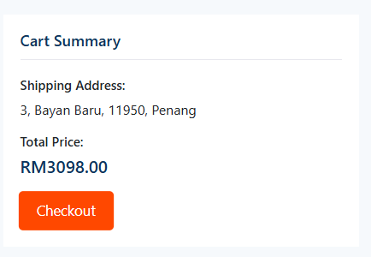

Appendix A40 Cart page show item is insufficient of amount to checkout  
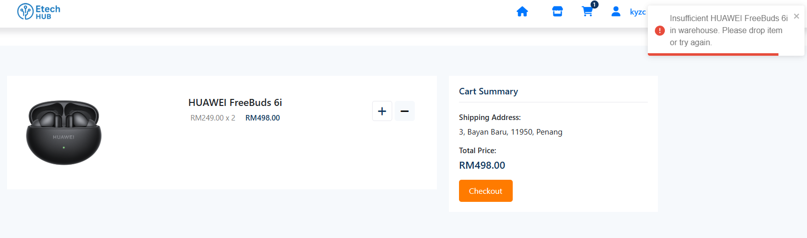  
  
  
  
  
  
  
Appendix A41 Cart icon show exactly the same amount with the items in cart  
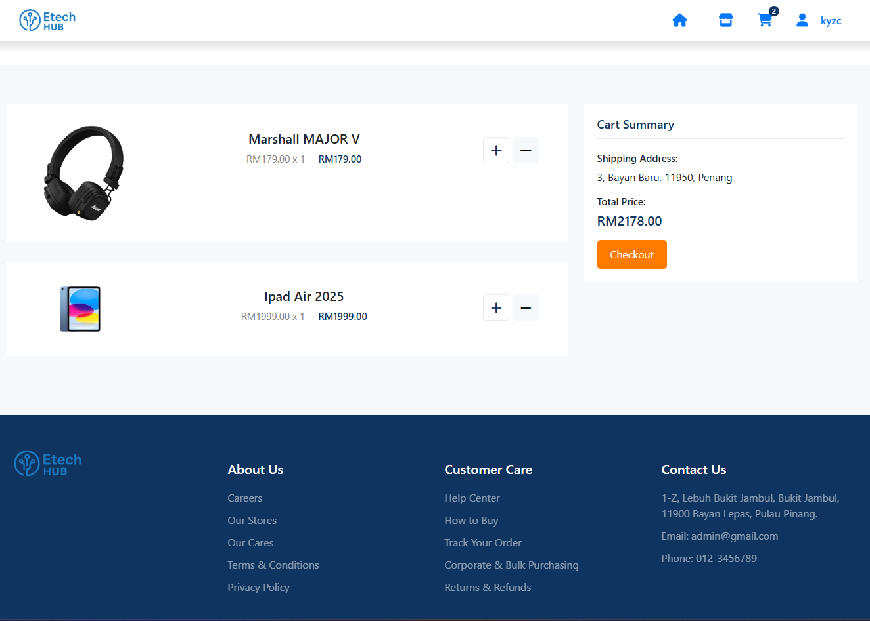  
  
Appendix A42 Massage show when user checkout successfully  
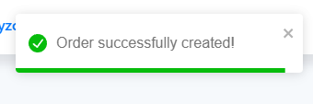

Appendix A43 User Profile fetch data from firestore and display correctly 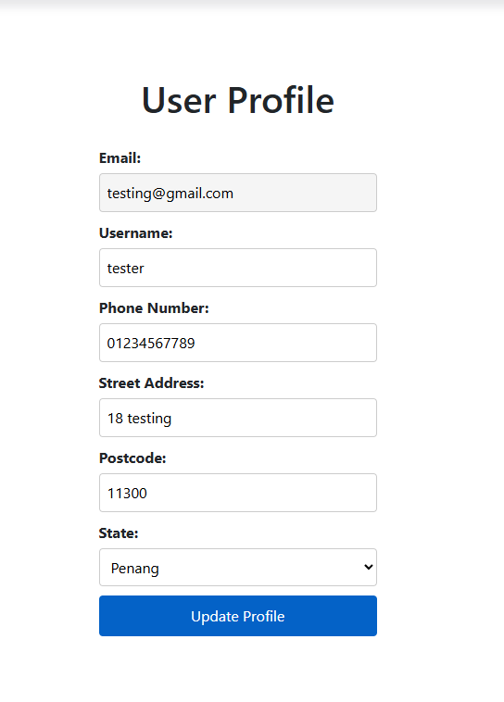

Appendix A44 Profile efit function is implement and function working properly  
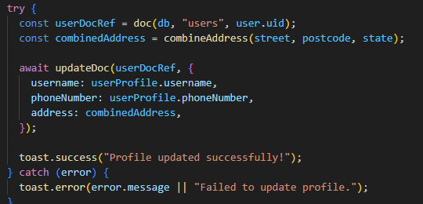  
Appendix A45 User profile cant be update if the field is empty and pop massage   
  
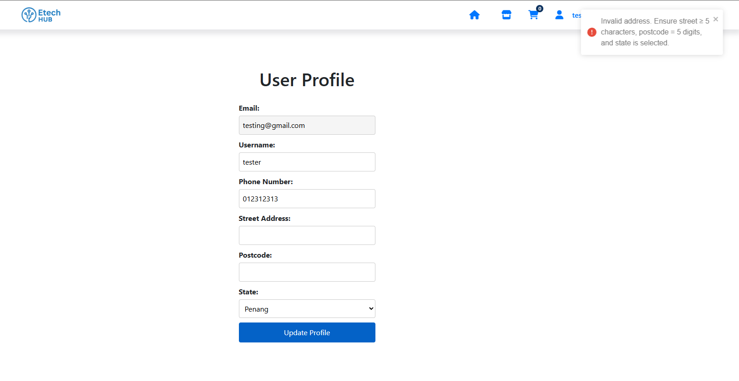  
  
  
Appendix A46 User Profile page show massage profile update succeesfully  
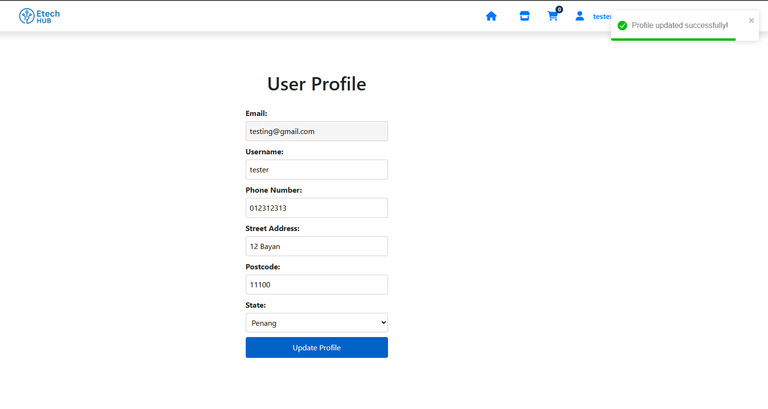

Appendix A47 User Profile show data is updated successfully and saved  
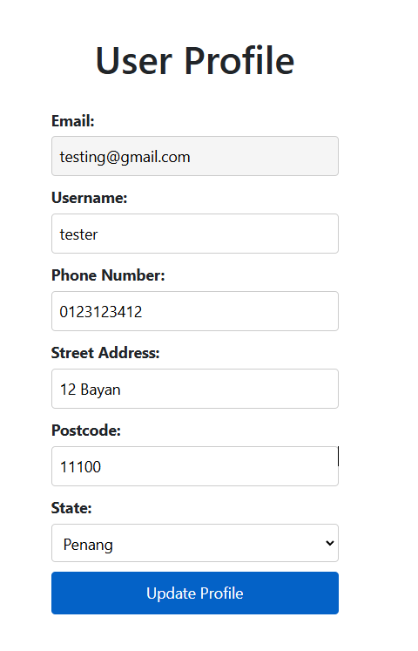  
  
Appendix A48 Track Order page Loads without error  
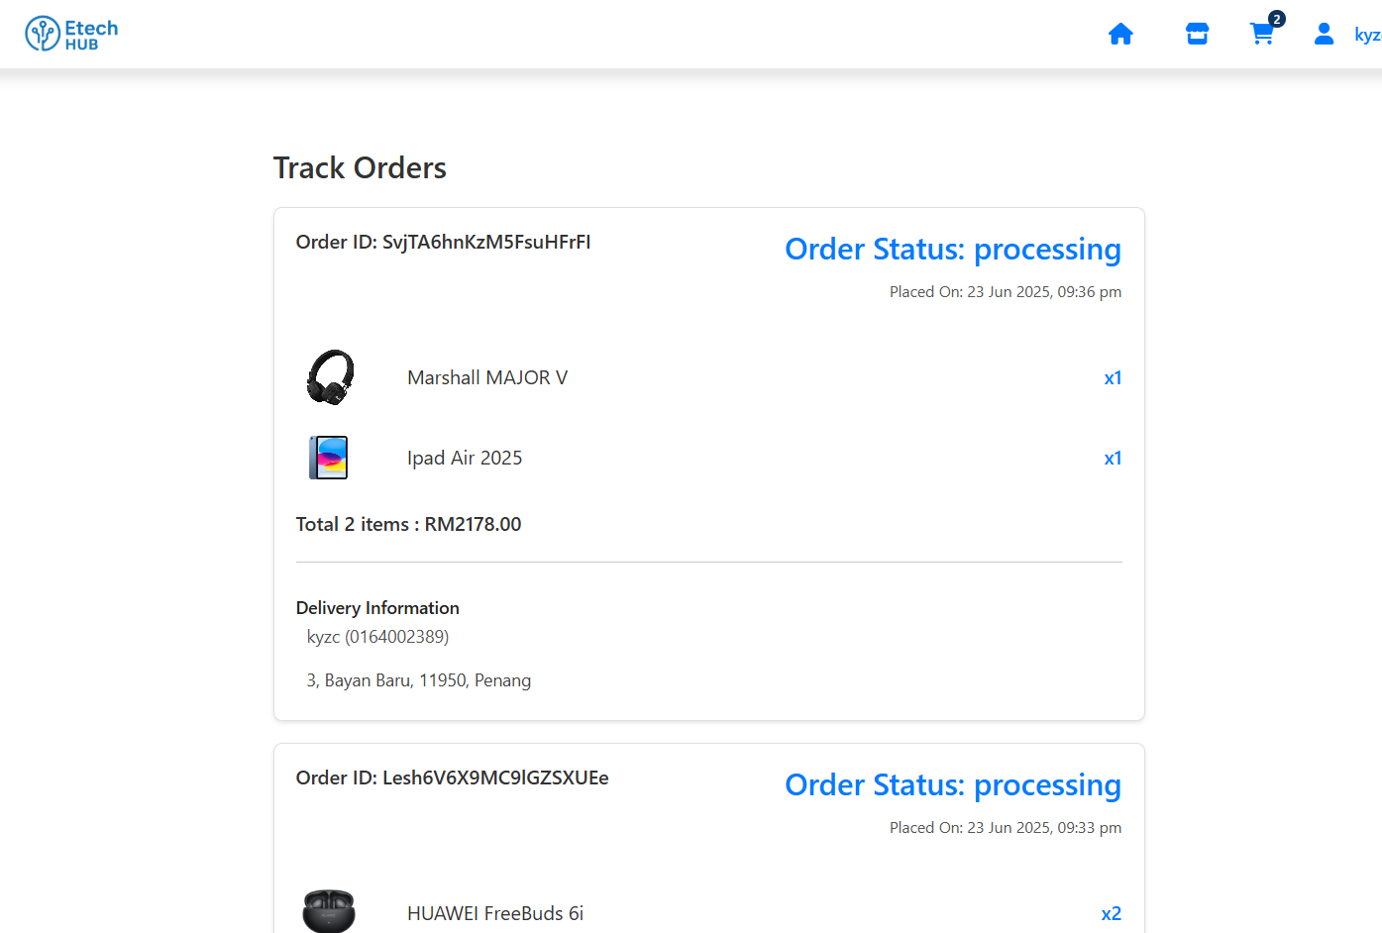  
Appendix A49 Track Order Page show individual order with Order ID   
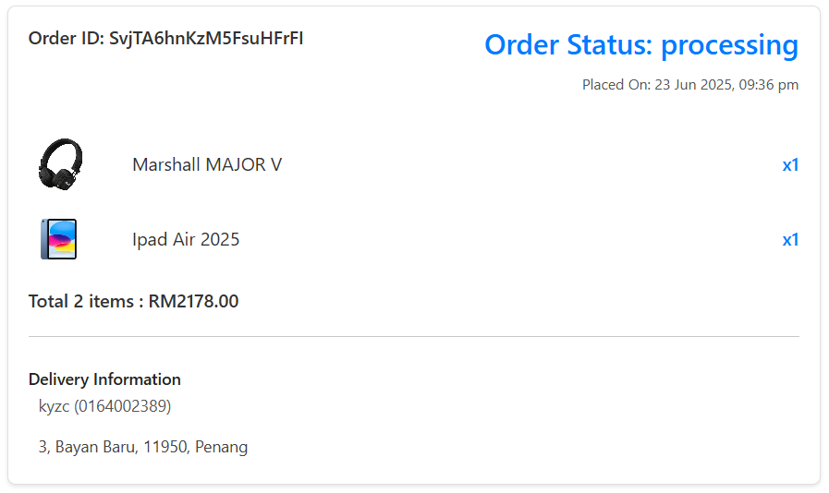  
  
  
Appendix A50 Track Order Page show Order Status correctly  
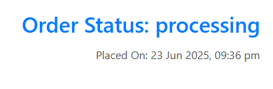

Appendix A51 Track Order page every order deteils is show correctly  
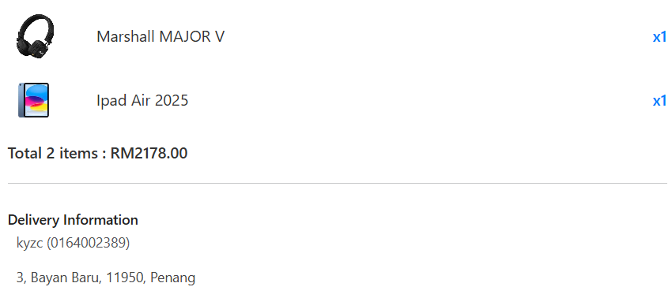  
  
Appendix A52 Admin Login page lunched properly  
  
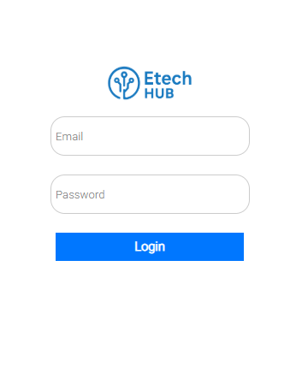  
  
  
Appendix A53 Admin login page show massage Please fill in both fields   
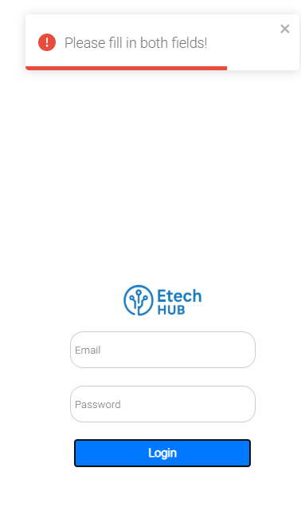  
  
Appendix A54 Admin login page show massage Please include an @ in the email address.

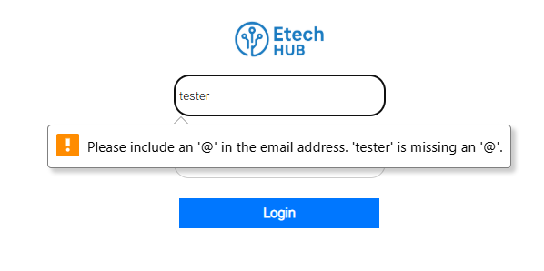

Appendix A55 Admin login page show massage Wrong email or password!  
  
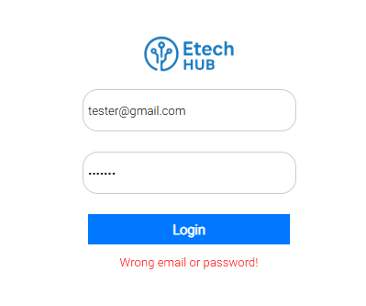  
  
Appendix A56 Dashboard page show properly after admin login  
  
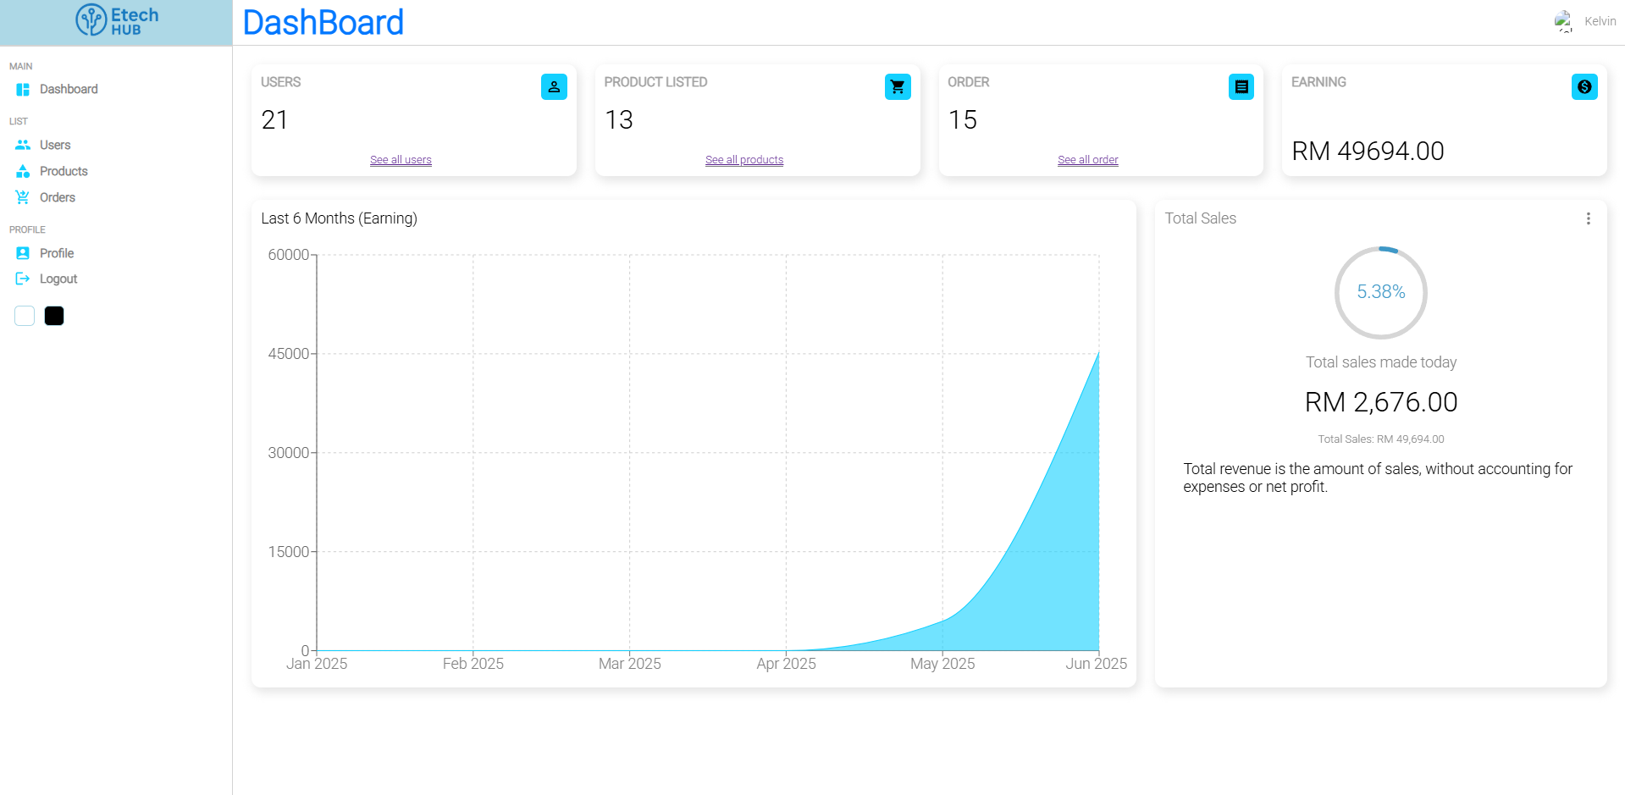  
Appendix A57 Dashboard page displays the total number of user gadgets, which matches the total user count  
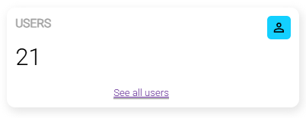

Appendix A58 Dashboard page displays the total listed of products, which matches the total product listed count  
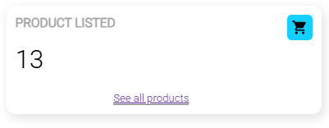  
  
Appendix A59 Dashboard page displays the total number of orders, which matches the total order count  
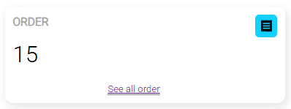  
  
Appendix A60 Dashboard page displays the total number of earning  
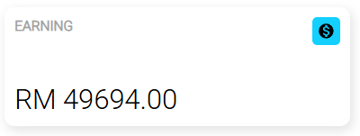

Appendix A61 Dashboard page show total daily earning  
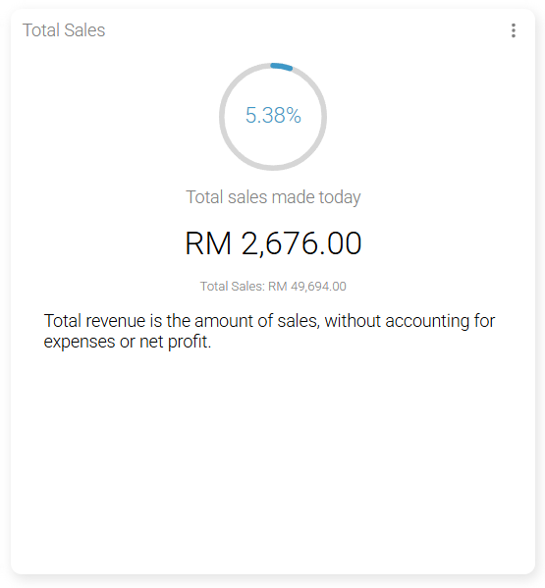  
  
Appendix A62 Dashboard page show the graph of earning display of past 6 month.  
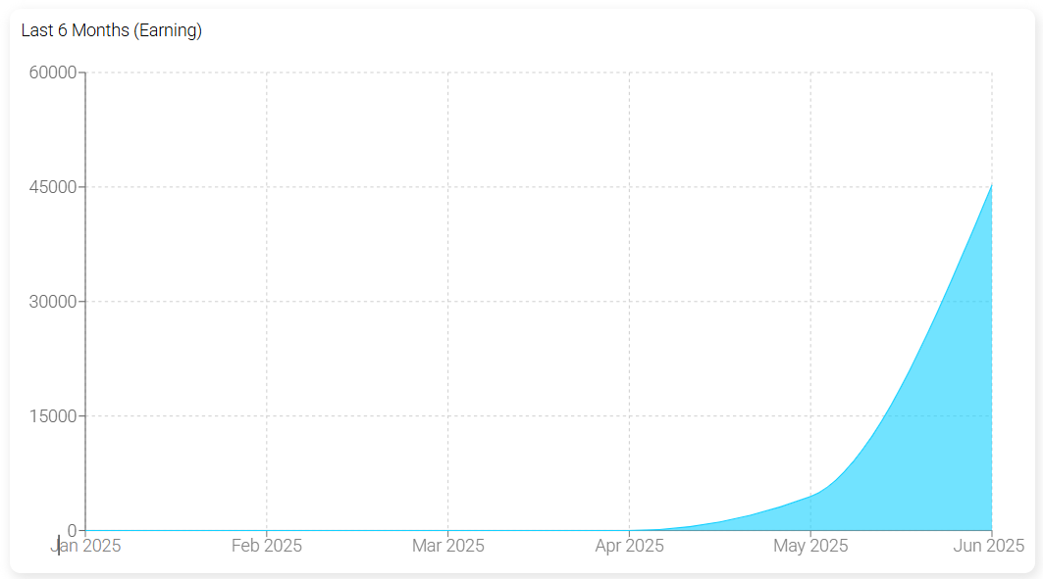

Appendix A63 Navigation side bar is working properly  
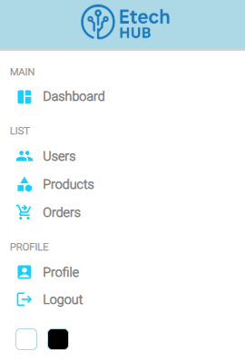

Appendix A64 User management dashboard   
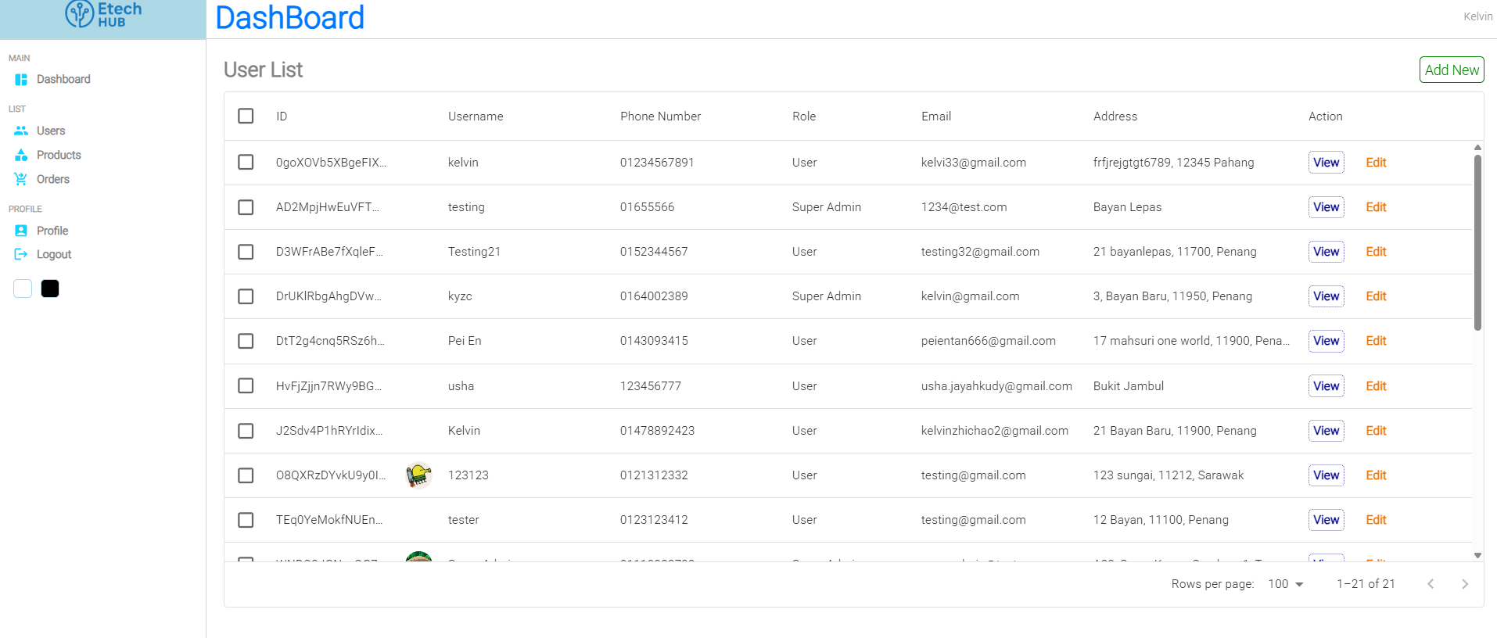

Appendix A65 User list with details  
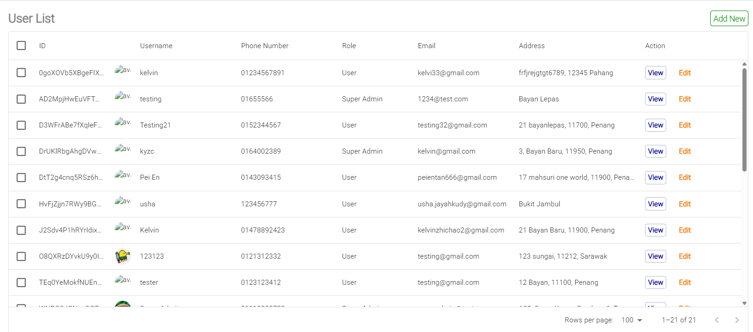

Appendix A66 User profile details 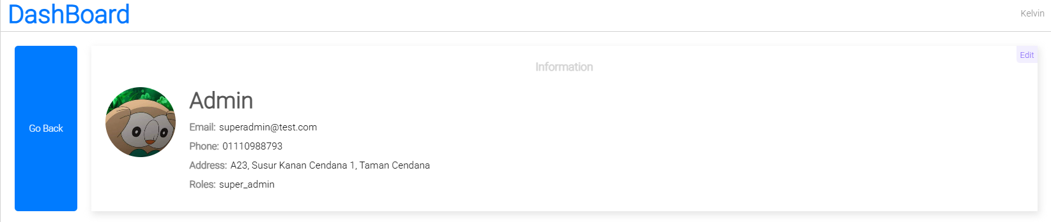

Appendix A67 User profile can be edit by admin  
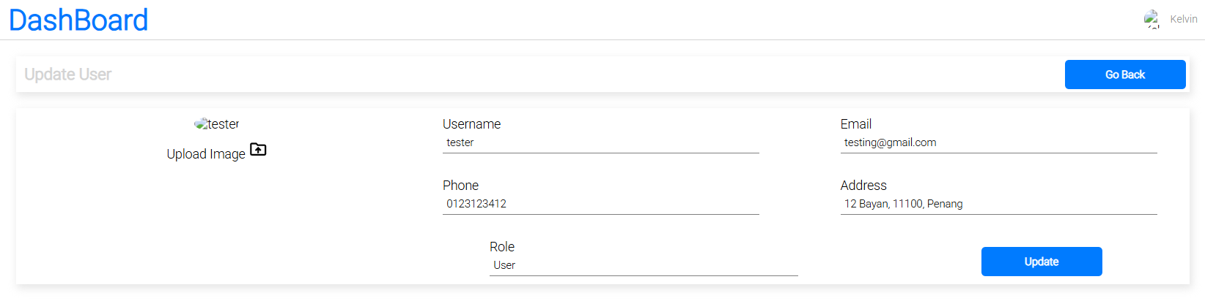

Appendix A68 User profile show massage Please fill in all required imformation before updating  
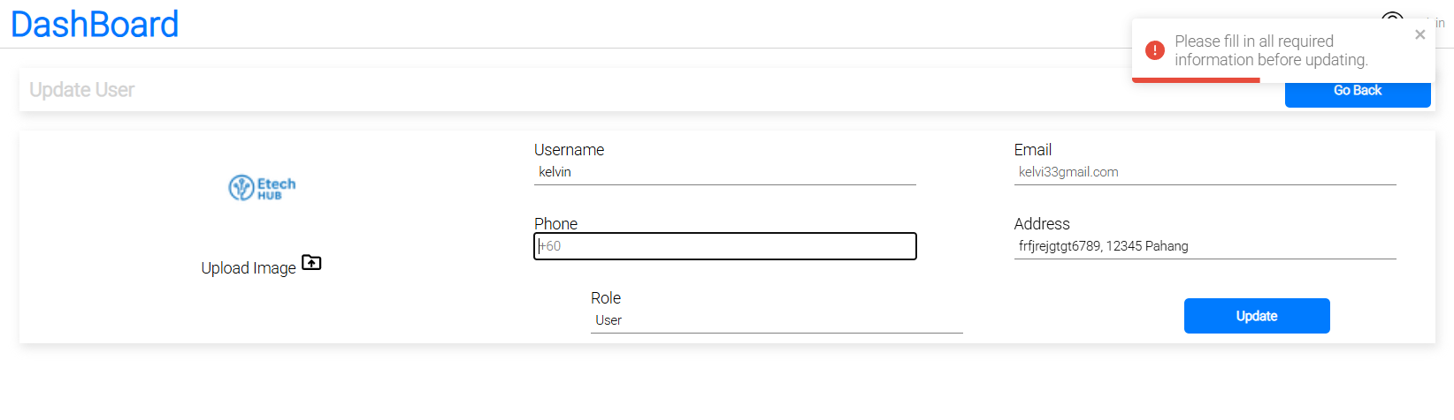

Appendix A69User profile info updated

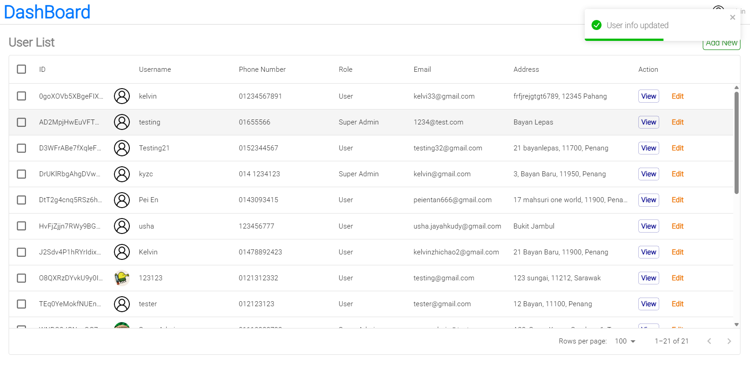  
  
Appendix A70 Create New User tab  
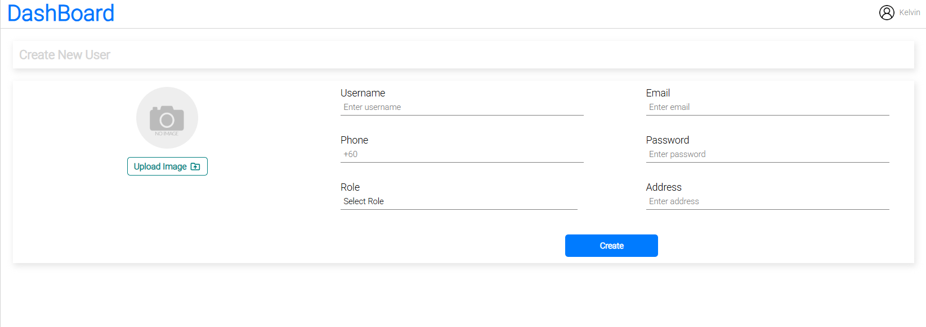

Appendix A71 Create New user tab show massage when email already in use  
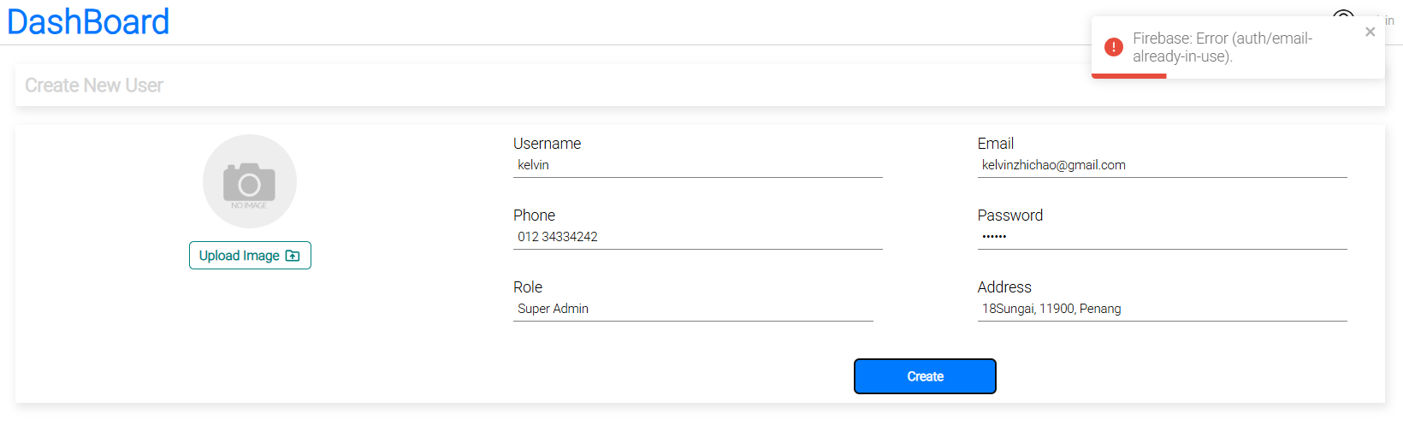

Appendix A72 Code snipped of Go Back function implemented  


Appendix A73 Update User tab show profile image upload   
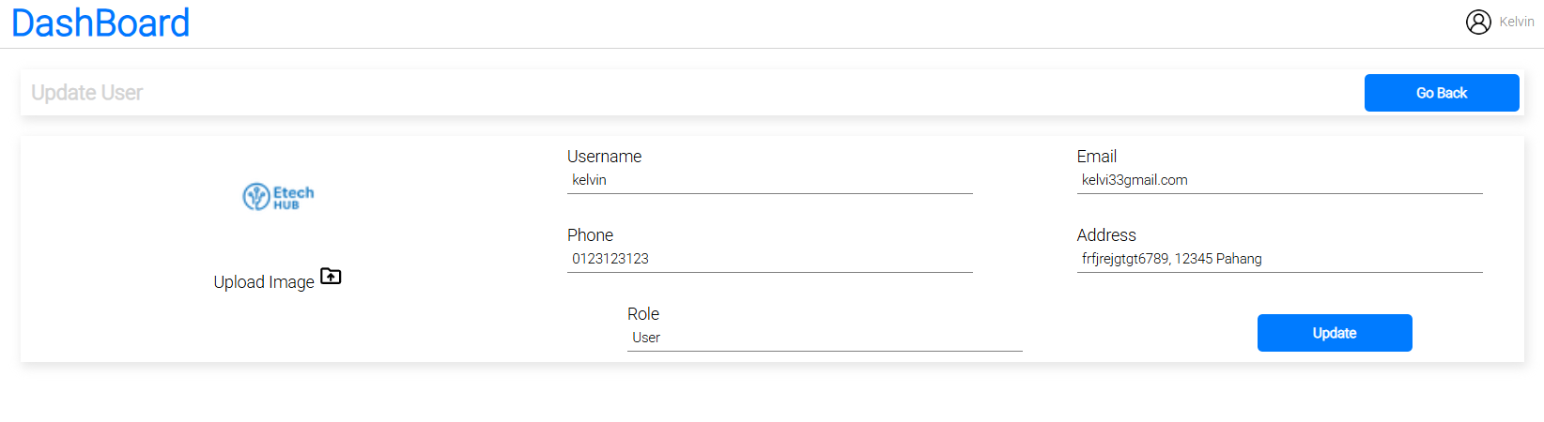

Appendix A74 Create User tab show profile image upload successfully  
  
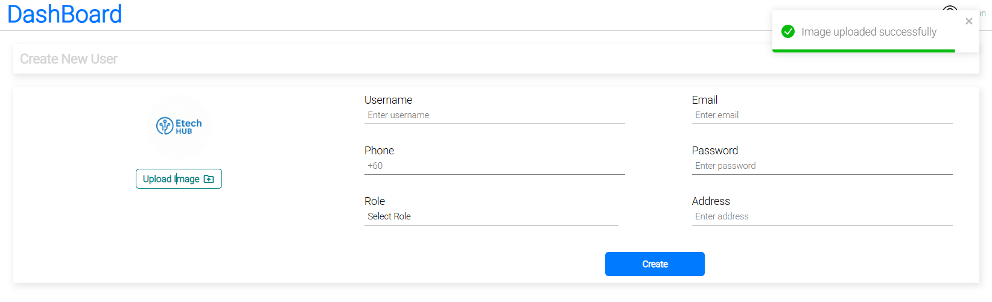

Appendix A75 Product List tab   
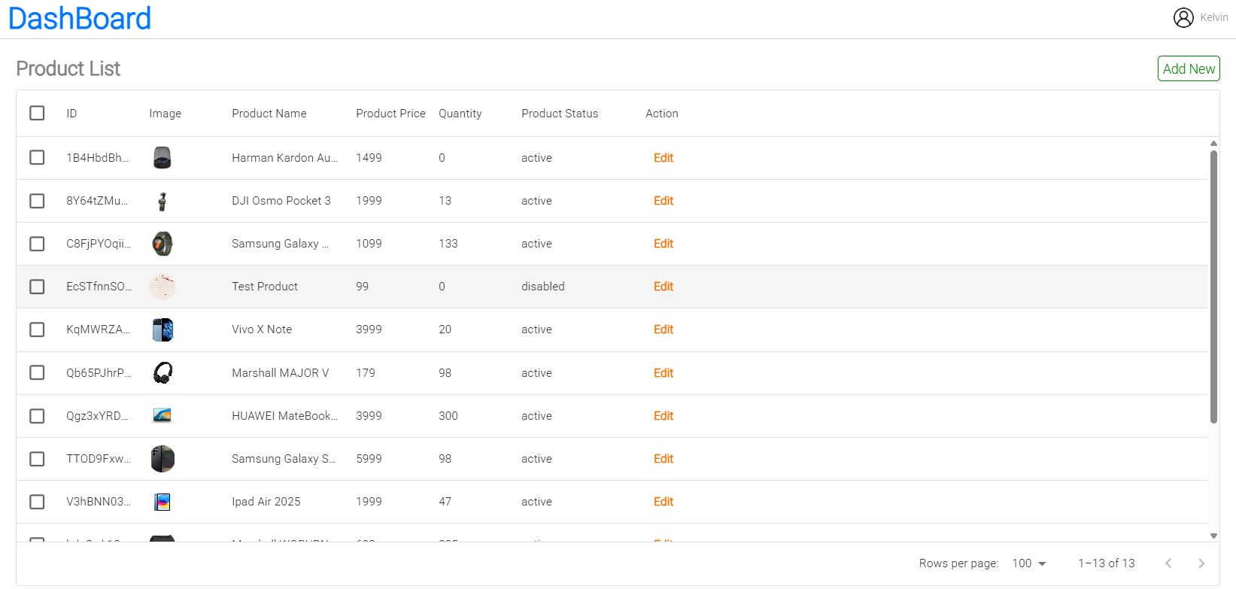

Appendix A76 Product info page  
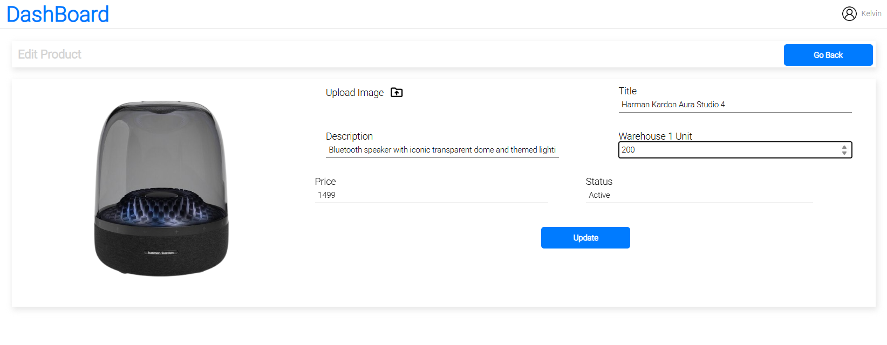

Appendix A77 Create New Product tab  
  
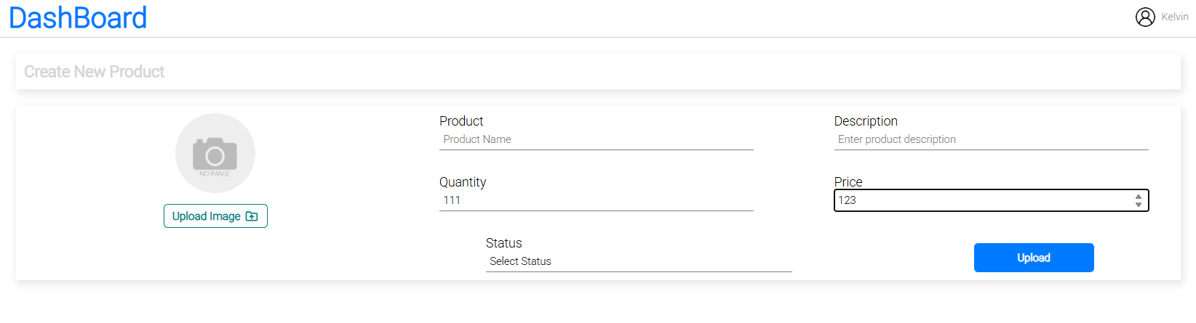

Appendix A78 Create New Product tab with product image uploaded  
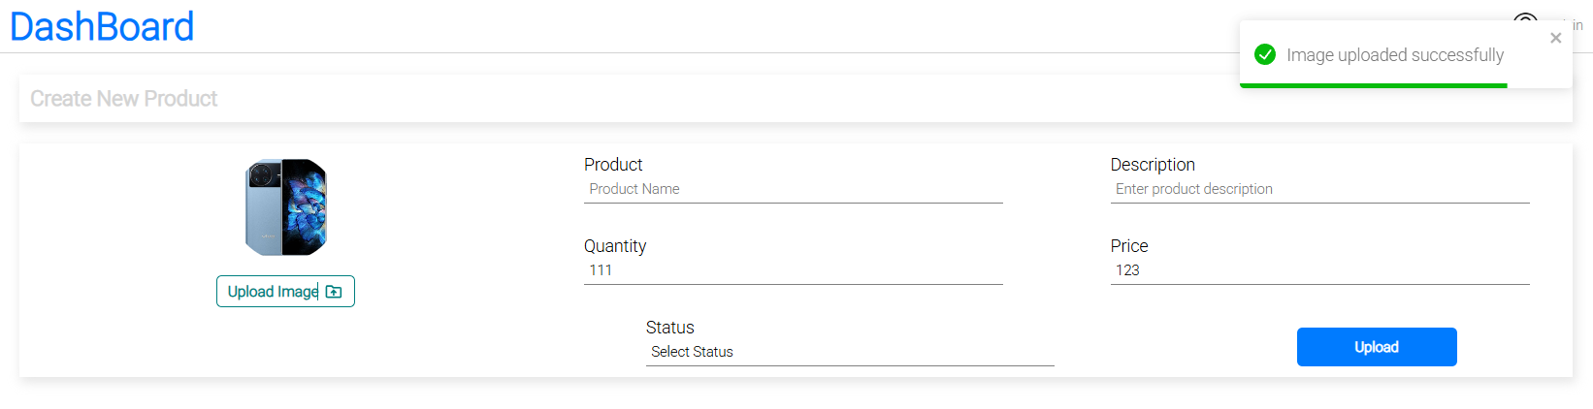

Appendix A79 Edit Product tab show all field can be edit  
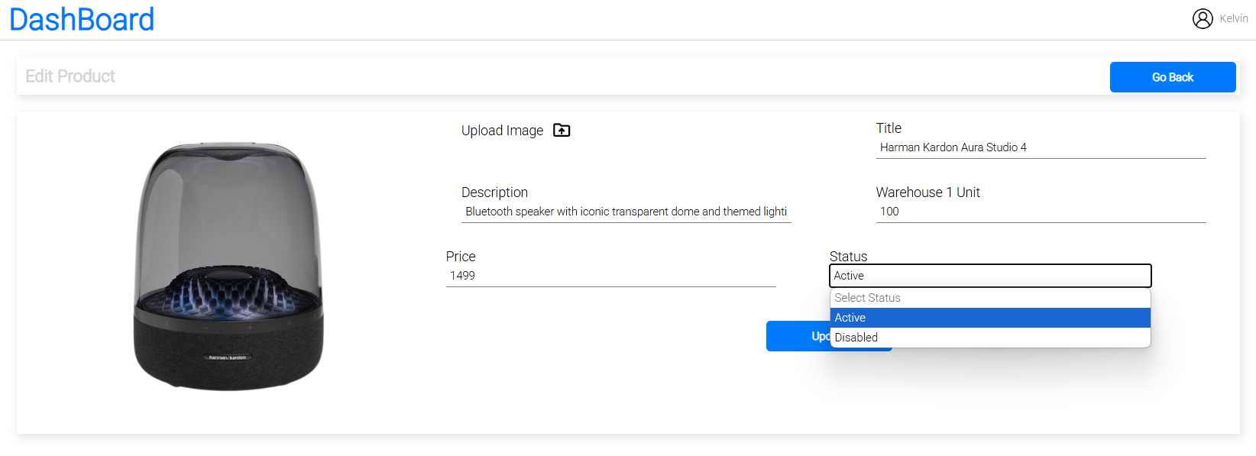  
  
Appendix A80 Edit Product page show massage Please fill in all required information before updating

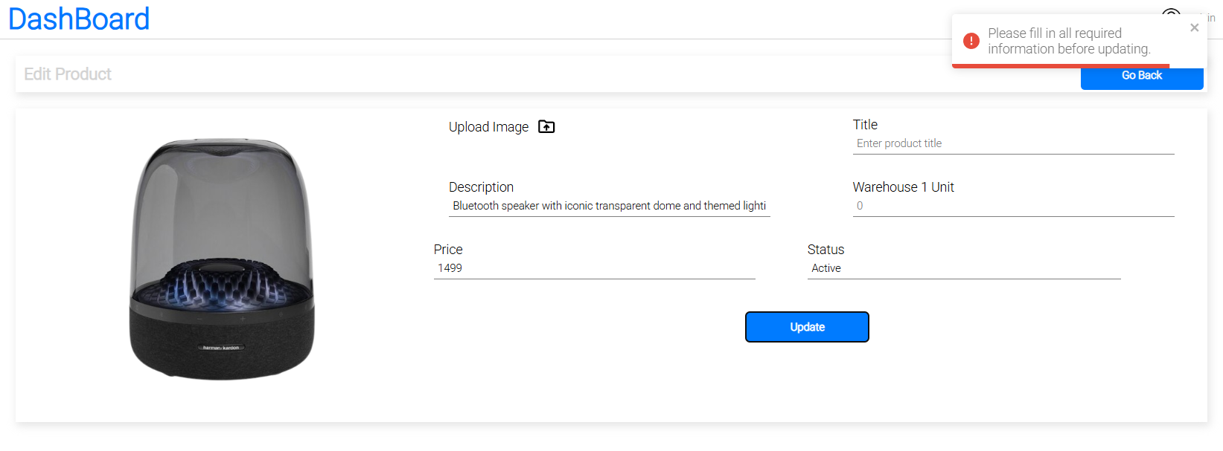

Appendix A81 Edit Product page show product price in number forms  
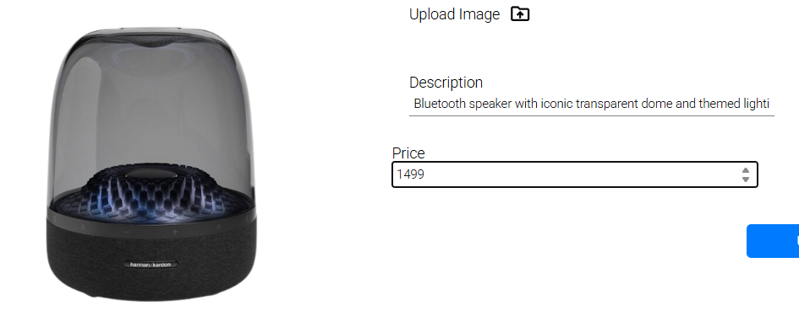  
Appendix A82 Product List page show that all catogary can be filtered  
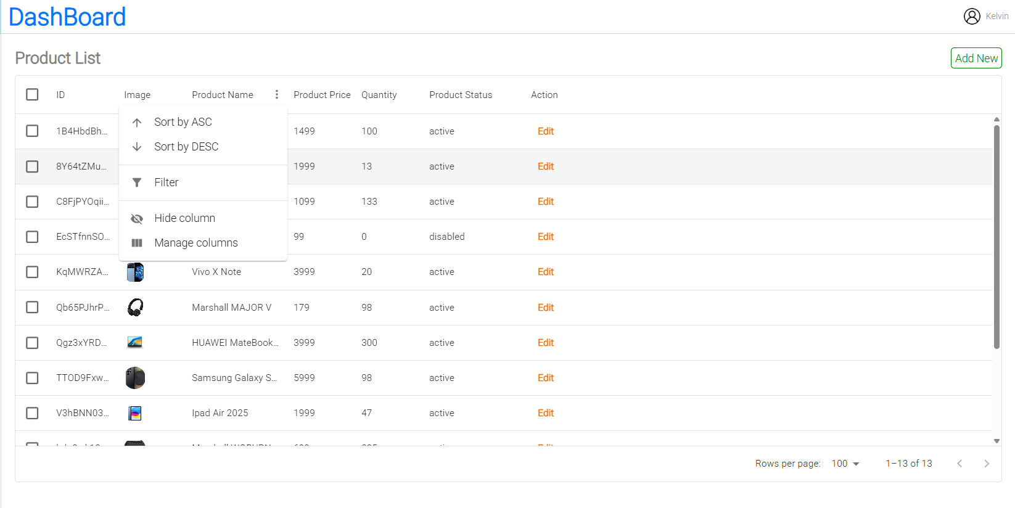  
Appendix A83 Order List Tab  
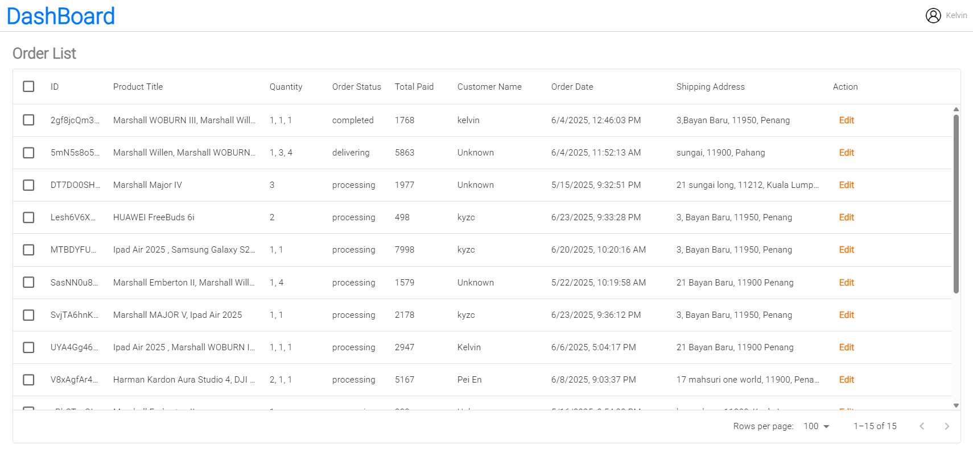

Appendix A84 Oder Detail tab can change the status of order

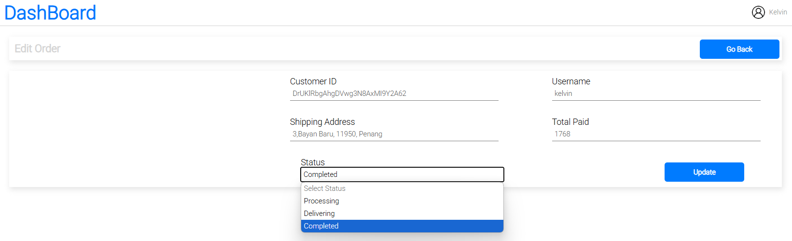  
Appendix A85 Order List Tab show customer tab is filtered by order   
  
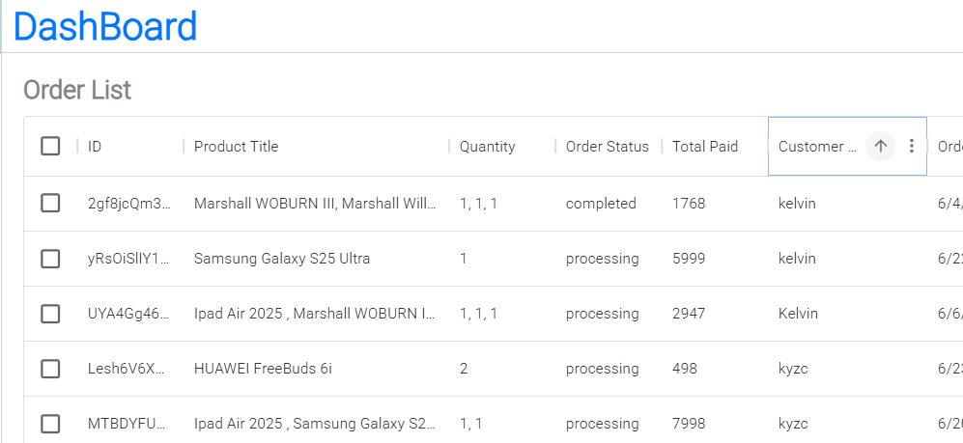  
  
Appendix A86 Order List Tab show order date can be sorted  
